10 useful tips to try when helping your child to regulate

For children ages 3 to 7, the goal is not to make emotions disappear. The goal is to help children recognize feelings, feel safe with them, and learn simple ways to manage them. Here are 10 of the most effective parent strategies.
1. Stay calm first  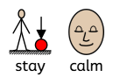  Children borrow emotional regulation from adults. When your child is upset, your calm voice, facial expression, and body language help their nervous system settle.  Try:  Speak more slowly, lower your voice, and take a breath before responding. | 2. Name the feeling  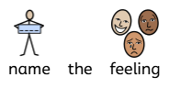  Young children often act their emotions because they cannot yet explain them. Giving feelings a name builds emotional awareness.  Try:  - "You seem frustrated."  - "You're disappointed because playtime ended."  - "It looks like you're feeling worried." | 3. Connect before correcting  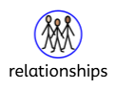  A child in a big emotional moment is usually not ready for a lesson or consequence. Connection helps them regain control.  Try:  - "I can see this is really hard right now."  - Then address the behaviour once they're calmer. | 4. Accept feelings, limit behaviours    All feelings are okay. Not all behaviours are.  Try:  - "It's okay to be angry. It's not okay to hit."  - "You can be upset, but I won't let you throw toys." | 5. Teach calming tools when calm  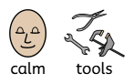  Children learn regulation skills best outside of emotional crises.  Try:  - Tummy breathing  - Counting to 10  - Squeezing a pillow  - Asking for a hug  - Taking a quiet break
6. Create predictable routines  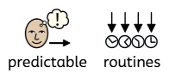  Young children regulate better when they know what to expect. Predictability reduces stress and emotional overload.  Focus on:  - Consistent bedtime  - Regular meals  - Transition warnings before changes | 7. Use play to teach emotions  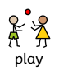  Play is a child's natural language. Books, dolls, puppets, and pretend play help children understand feelings and coping strategies.  Example: Act out a character who feels angry and practices taking deep breaths. | 8. Help them notice body signals  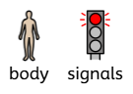  Emotions often show up in the body before children recognize them mentally.  Ask:  - "What does your body feel like when you're angry?"  - "Do your hands get tight or your tummy feel funny?"  This builds self-awareness, a key regulation skill. | 9. Praise regulation efforts, not perfection  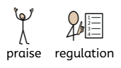  Notice and reinforce attempts to manage emotions.  Instead of: "Good job not crying."  Try: "I noticed you took a deep breath when you got upset. That helped you calm down." | 10. Remember that co-regulation comes before self-regulation  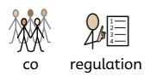Children aged 3 to 7 are still developing the brain skills needed for emotional control. They need adult support repeatedly before they can regulate independently.  Think of yourself as a coach rather than a referee.  A useful phrase is:  "I see you're feeling angry. I'm here with you. It's okay to feel angry. Let's take some deep breaths and figure out what to do next."  Children who experience this pattern consistently gradually learn to do these steps for themselves.

